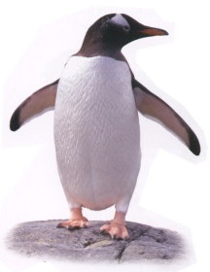
Exploring Simultaneous Equations

Dr Doolittle decided to create a retirement home for old animals. He employs Jim and Jane to look after the animals while he is away. When he returns from a trip to Africa he asks them to go and see how many animals there are in the home.

1. Jim said that in the Camel cage there were 60 camel legs.
How many Camels were there?
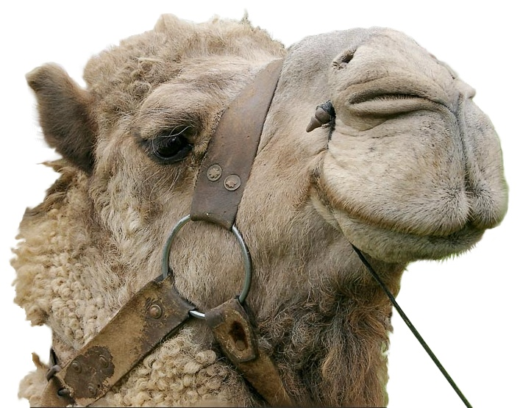
2. Jane said that in the Penguin pool there were 68 penguin legs.
How many Penguins were there?

3. Jim and Jane said that there were some Flamingos in the Rhino enclosure. There were 56 legs altogether, including 6 Rhinos.
How many Flamingos were there?

4. Jane said that some Stag Beetles (6 legs) and 6 Newts had a total of 66 legs.
How many Stag Beetles were there?
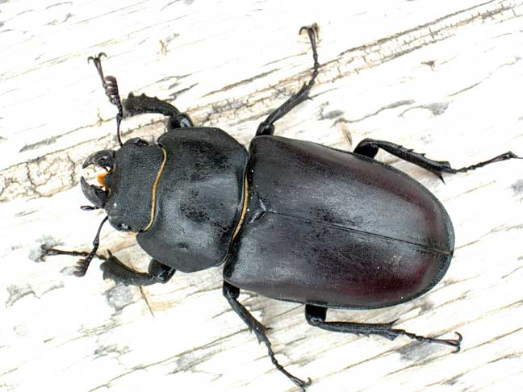
5. Jim said that in the Giraffe and Elephant enclosure there were 12
heads in total.
How many Giraffes and Elephants could there be?
(Find all the answers you can)

6. Jim said that in the Buffalo and Ostrich enclosure there were 52
legs in total.
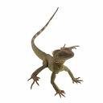
How many Buffalo and Ostriches could there be? (Find all the answers you can)

7. Jim said that in the Snake and Lizard reptile house there were 10 heads in total.
How many Snakes and Lizards could there be? (Find all the answers you can)

8. Jane also noted that in the Snake and Lizard reptile house there were 28 legs in total.
How many Snakes and Lizards were there?

9. Jim and Jane said that there were some Peacocks and Rhinos together. There are 14 heads and 46 legs in total.
How many Peacocks and Rhinos were there?

10. Jane said that in the pool house there were some Octopuses and Penguins. There were 12 heads in total and 48 legs in total.
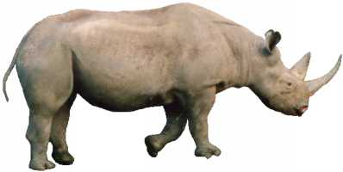
How many Octopuses and Penguins were there?

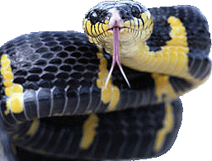
Teaching Approach:

1. Give the pupils the problems to solve by whatever method they choose.
2. Questions 6 and 7 have several solutions
3. Questions 7 and 8 are linked to produce one solution.
4. Discuss listing possible solutions
5. Discuss drawing graphs to show the solutions
6. Break Questions 9 and 10 into 2 questions and solve independently - Listing outcomes
- Drawing graphs
7. Explore ways of writing the problems out using algebra – focus on the correct meaning of the letters – so for example in Q1 they might use C to stand for the number of Camels.
8. Question 10 results in x + y = 12 and 8x + 2y = 48. On a graph show that the solution is the intersection but also show that if you add or subtract the 2 equations the line still passes through the solution.

So 8x + 2y = 48
x + y = 12 -
7x + y = 36 also passes through the solution

So 7x + y = 36
x + y = 12 -
6x = 24 also passes through the solution

So 6x = 24 which is the same as x = 4 etc….

9. More complicated versions of these problems can be made by changing them to problems such as:
4 cups of coffee plus 3 cups of tea costs £1.62
5 cups of coffee plus 2 cups of tea costs £1.73

It can be made even harder by introducing a soft drink in the bill.

- Get the pupils to make up their own equations for each other to solve. Suggest they start by drawing a picture of their animals and then create the questions.

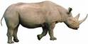

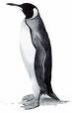
4x + 2y = 38

There are some Rhinos and some Penguins together.
There are 15 heads
There are 38 legs
x is the number of Rhinos and y the number of Penguins
x + y = 15

If these cards were produced on a computer the they would result in an excellent card sort activity.
x y
1 14
2 13
.. ..
x y
1 17
2 15
.. ..

